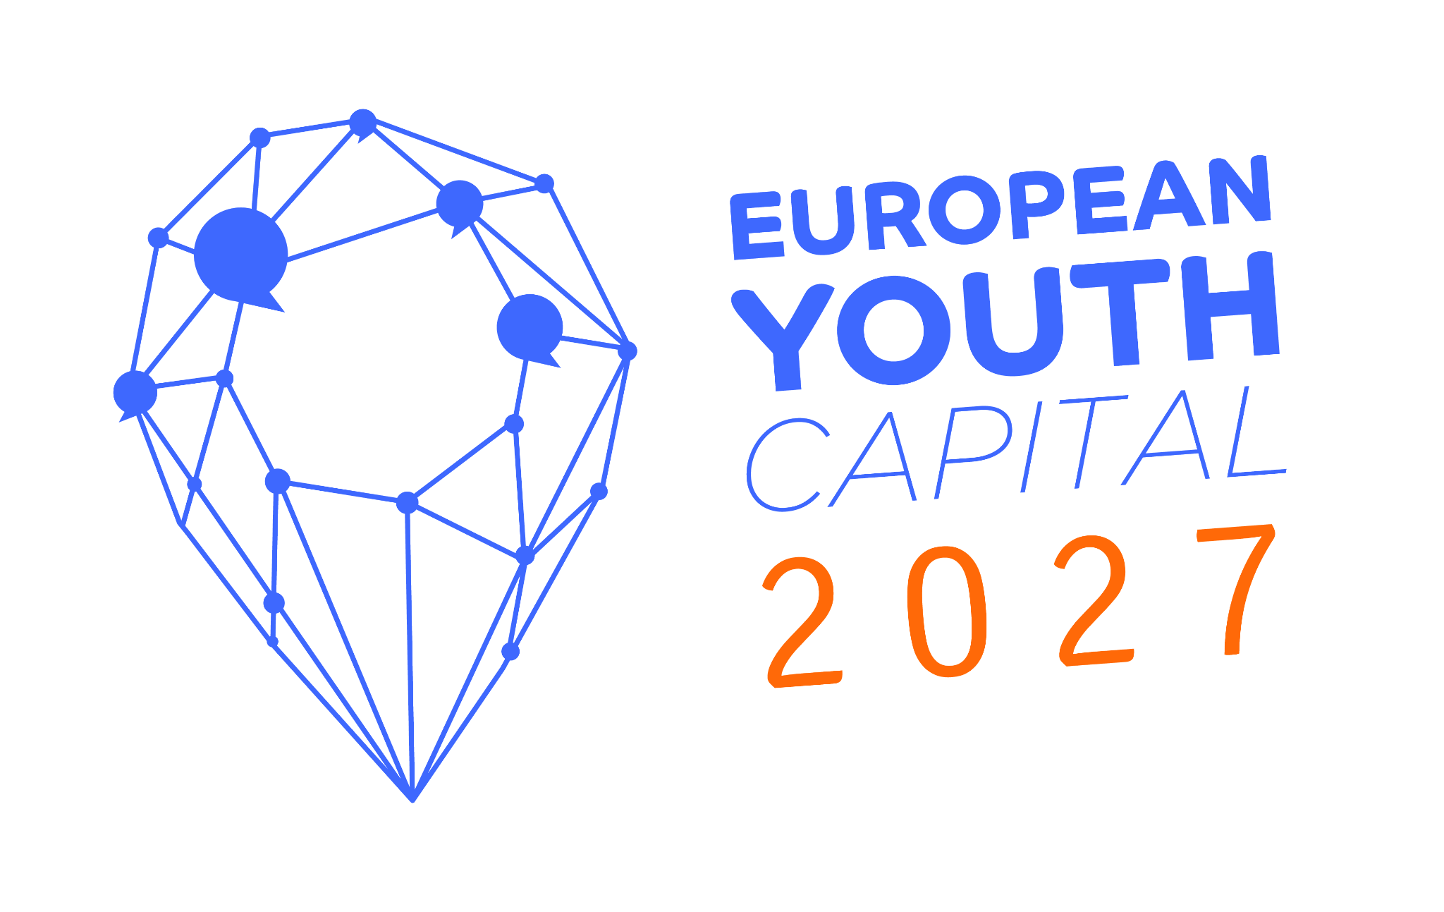

First Round
APPLICATION FORM
2027

Instructions

Deadline for submitting the First Round Application Form:
13th of february 2024 (23:59 CET)
Applications and documents submitted after the deadline will not be considered eligible.

Applications need to be submitted to the following email address:
eyc@youthforum.org
Applications and documents submitted by other means will not be considered eligible.

Please refer to the questions and instructions in the Application Questionnaire for further details about the information you should provide.

Eligibility guidelines
Applications ignoring the below mentioned requirements will not be considered eligible:
- The First Round Application Form must be written in the Arial 11-pitch font.
- All information, including Annexes, must be written in English.
- The answers to the questions from 1 to 9 altogether cannot exceed 15 pages limit.
- The First Round Application Form must be submitted both in Word and PDF files.
- The Annexes in question 10 are mandatory. However, the applicants can submit additional Annexes as they see fit. Each Annex cannot exceed a limit of 10 pages.
- Please note that all photographs have to be added in the Annexes.
- The applicants can design their application, including the cover page the way they want. However, the order of the questions must remain the same as in the First Round Application Form template.
- Support letters or any other documents sent by the applicants to the European Youth Forum after the application deadline and not as a part of the application package are not considered and forwarded to the European Youth Capital Jury.
All applications must include proof of payment of the €300 application fee. The fee needs to be received by the Youth Forum before the first application deadline. Please see the details of the European Youth Forum bank account below.

EUROPEAN YOUTH FORUM BANK DETAILS
Name of Bank | ING bank  Marnix Business Branch
Address of bank | 1, rue du Trône  1000 BRUXELLES  BELGIUM
SWIFT or BIC code | BBRUBEBB
Account number | 375-1009152-43
IBAN | BE66 3751 0091 5243

APPLICANT INVOICING DETAILS

Name of entity to be invoiced
Legal address
Registration number
VAT number (if applicable)
Your reference (if applicable)
Contact person

https://www.youthforum.org/topics/youthcapital

EUROPEAN YOUTH CAPITAL (EYC) 2027 FIRST ROUND APPLICATION FORM

A. APPLICANT

Municipality
Region
State
Total population
Population under 35 years old

B. MUNICIPAL LEGAL REPRESENTATIVE

Surname
First Name
Position
Address | Street/Number | Postal Code |  | City |  | State
Phone
E-Mail
 | Municipal Service Coordinator
Surname
First Name
Position
Address | Street/Number |  | Postal Code |  | City |  | State
Phone
E-Mail
Webpage of the city
 | Contact person (if different than the two persons above)
Surname
First Name
Position
Address | Street/Number |  | Postal Code |  | City |  | State
Phone
E-Mail

C. SUPPORTING YOUTH STRUCTURE(S)

Name of Organisation
Address of Organisation | Street/Number | Postal Code | City | State
Phone
E-Mail
Web page
 | Contact Person
Surname
First Name
Position
Address | Street/Number | Postal Code | City | State
Phone
E-Mail

For Questions 1 - 9, please refer to the Application Questionnaire. We offer this Application Form as an easy format in which you can insert your answers, but other formats will also be accepted, as long as they fulfil the eligibility guidelines.

1. HISTORY AND SITUATION FOR YOUNG PEOPLE
The applicant is asked to describe the city’s past performance in the youth field, and the current situation for young people in the city.
The Candidate is asked to emphasise the areas of youth policy, youth services, and youth-related developments in the last years in order to outline context in which this application is submitted. Emphasis on social and environmental sustainability should be included.
Fill in you answer here:

2. MOTIVATION AND GOALS
The Candidate is asked to describe the motivation behind the application for the European Youth Capital, and to outline how and by whom the application itself has been prepared, and what main reasons there are for applying to become the EYC.
Fill in you answer here:

3. YOUTH AND PUBLIC EVENTS INFRASTRUCTURE
The Candidate is asked to describe the city’s capacity to host the European Youth Capital in terms of infrastructure (venues, accommodation, transportation) . The Candidate should make clear how this infrastructure would be used to support the EYC and youth representatives, especially during (international) meetings and events.
Fill in you answer here:

4. EUROPEAN YOUTH CAPITAL PROGRAMME
The Candidate is asked to present an outline of its programme for the European Youth Capital. While we do not expect a fully-fledged programme at this stage of the process, the application should include general indications as to the key components of the EYC programme. Please address as many aspects as possible, while emphasising social and environmental sustainability.
Fill in you answer here:

5. IMPACT AND LONG-TERM LEGACY
The applicant is asked to describe the desired long-term impact and legacy that you intend for the European Youth Capital title to have on the city. It should be coherently linked with previous sections, notably motivation, key goals, and the proposed programme, and present how the city would move towards long term effects of the EYC. Emphasis on social and environmental sustainability should be included.
Fill in you answer here:

6. YOUTH PARTICIPATION
The Candidate is asked to outline the involvement of young people in all stages of the EYC process.
Fill in you answer here:

7. MANAGEMENT
The Candidate is asked to describe the governing, decision making, and implementation structures of the proposed EYC with a specific emphasis on youth involvement in all of the aforementioned bodies. We recommend including diagrammes and similar visual aids where relevant.
Fill in you answer here:

8. BUDGET INDICATIONS
The Candidate is asked to indicate the budget foreseen for the EYC. The budget must be coherent with the proposed programme and other activities linked to the preparation, implementation, and the follow-up of the EYC year.
Fill in you answer here:

9. EUROPEAN YOUTH FORUM EVENTS
By accepting the EYC title, the Awarded City commits to host the European Youth Capital Award Ceremony and, if agreed between the Awarded City and the European Youth Forum, to host the Statutory Meeting (Council of Members) of the European Youth Forum
Please provide a brief overview of the city’s capacity to host such events in terms of possible contribution with resources, income and allocation. For more information on the financial and administrative responsibilities that are associated with the events, please refer to the EYC Legal Terms and Conditions.

10. ANNEXES – please include the following:

ANNEX I: Written proof of the town or city’s interest in running for EYC 2027 (to be signed by the head of executive of the municipal authority).

ANNEX II: A signed and stamped statement of support by an independent local or regional youth council. If no local youth council exists, a relevant coalition of local youth NGOs should support the application with the municipality, in written form.

ANNEX III: A signed copy of the legal terms and conditions of the competition for the European Youth Capital (to be signed by the head of executive of the municipal authority).

ANNEX IV: A proof of the bank transfer of the application fee of €300, to the Youth Forum bank account details provided below. Note that the European Youth Forum will need to issue an invoice acknowledging the receipt of the payment, thus please together with the proof of payment provide the following information: full name, address, registration number of the entity making the payment.

ANNEX V: A statement declaring any external support (e.g. consultant services) requested to prepare the application, if applicable.

https://www.youthforum.org/topics/youthcapital

The limit of 15 pages relates to the PDF version, not to the number of characters. In other words, if you also include pictures, tables, or charts, these do count to the 15-page limit, and questions 1 to 9 cannot exceed 15 pages in the PDF export.
Both files must be identical.
Please refer to the Annex II for clarification.
As photograph, we understand a picture produced using a camera, thus any kind of graphs, charts etc. that would help to make the application clearer and together with the written text do not exceed the page limit are welcome. Source: Cambridge Dictionary, https://dictionary.cambridge.org/dictionary/english/photograph.

